Software Requirements Specification
For
StudEasy
Version 1.0 approved
Prepared by:
Ushna Nadeem (i211225),
Taimoor Anwar (i211232),
Hamna Riaz (i211201),
January 02, 2023
Table of Contents
Table of Contents ii
Revision History ii
1. Introduction 1
1.1 Purpose 1
1.2 Document Conventions 1
1.3 Intended Audience and Reading Suggestions 1
1.4 Product Scope 1
1.5 References 1
2. Overall Description 2
2.1 Product Perspective 2
2.2 Product Functions 2
2.3 User Classes and Characteristics 2
2.4 Operating Environment 2
2.5 Design and Implementation Constraints 2
2.6 User Documentation 2
2.7 Assumptions and Dependencies 3
3. External Interface Requirements 3
3.1 User Interfaces 3
3.2 Hardware Interfaces 3
3.3 Software Interfaces 3
3.4 Communications Interfaces 3
4. System Features 4
4.1 System Feature 1 4
4.2 System Feature 2 (and so on) 4
5. Other Nonfunctional Requirements 4
5.1 Performance Requirements 4
5.2 Safety Requirements 5
5.3 Security Requirements 5
5.4 Software Quality Attributes 5
5.5 Business Rules 5
6. Other Requirements 5
Appendix A: Glossary 5
Appendix B: Analysis Models 5
Appendix C: To Be Determined List 6

Revision History
Name | Date | Reason For Changes | Version
I211225_i211232_i211201_Q_V1.0 | October 16, 2022 | - | 1.0
I211225_i211232_i211201_Q_RS_V2.0 | January 02, 2023 | Detailed description of functional and non-functional requirements with some changes. | 2.0

Introduction

Purpose
This document's goal is to compile, examine, and describe high-level StudEasy requirements and features. It emphasizes on the capabilities required by stakeholders and target users, as well as the reasons behind these needs. The use-case and supplemental specifications go into detail on how the StudEasy satisfies these requirements.

Document Conventions
SQL- Structured Query language
PHP- Hypertext preprocessor
API- Application programming interface

Intended Audience and Reading Suggestions
This document is intended for developers, project managers, marketing staff, testers, and writers of documentation. The document is organized as follows: First, we have the introduction, which contains the purpose, document conventions, intended audience, reading suggestions, product scope, and reference for all the readers. The overall description, which is intended for developers, project managers, testers, and writers of documentation, includes the product perspective, product functions, user classes and characteristics, operating environment, design and implementation constraints, user documentation, and assumptions and dependencies. Then there are External Interfaces Requirements, which cover everything from user interfaces to hardware interfaces to software interfaces to communication interfaces for readers of all kinds. The next category is System features, which include three system features that are appropriate for all audiences. The remaining nonfunctional requirements include software quality attributes, safety and security requirements, performance requirements, and business rules for all reader types. Finally, we have additional requirements, including a glossary, analysis models in Appendix B, a list of to-be-determined items, and a revision history for all readers.

Product Scope
This Vision Document is applicable to the StudEasy, which our software development team will create. This client-server system will be created by the development team to connect with the current university systems. According to their academic standing and financial situation, undergraduate students can shortlist the universities offering scholarships and student loans through the StudEasy onboarding procedure. By entering their credentials into the student information page without revealing any personal information, the system enables the user to find the appropriate universities. The system, however, only lists and displays the university websites that the student is qualified to attend based on the data entered.

References
IEEE Recommended Practice for Software Requirements Specifications, IEEE Standard 830, 1999.

Definitions, Acronyms, and Abbreviations
StudEasy- “Financially fit for your academic progress.”
HEC- Higher Education Commision

Overall Description

Product Perspective

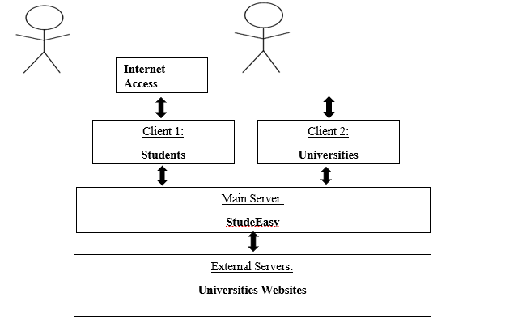

Product Functions
Following are this product’s main functions:
- Profile Management of both Universities and Students
- Register/Signup/ Login
- Logout
- Upload Certificates/Achievements
- Redirect Student to University Website
- Import/Fetch Student Data to University Application Forms
- Search/Filter
- Maintain Wishlist
- Maintain History
- Notifications
- Helpline/Chat box
- Display Allocated Scholarship Amount
- Live Update of Scholarships
- Total Available Scholarships
- Total Number of Universities Offering Scholarships
- Number of Students Applied for a Specific Scholarship
- Degree on which Scholarship is Available
- Eligibility Criteria
- Deadlines
- Scholarship Duration
- Total Students Availing Scholarships through StudEasy
- Reviews of Universities and Feedback of Students

User Classes and Characteristics
Students and Universities are the two categories of StudEasy users. Although the user should have a basic understanding of registration, the interface itself is very predictable, making it easy for a novice user to comprehend and use the system. StudEasy also has a "Help" page that contains all the help a user may require at any time while using our web app.

Operating Environment
The student interface, and the University interface are our two user interfaces. Because it is a web application, all three interfaces must work on PCs, laptops, and mobile phones, require only internet connection and any search engine.

Design and Implementation Constraints

Security

Maintainability and safety of the user’s account and data.

StudEasy will ensure the security of the student’s data by securing the website’s URL and using authentication processes such as log in portals whenever someone wants to access their account.

Usability

StudEasy is a user friendly and easy to use website.

Students can look up for their required information in a click.

Students can have their own accounts and manage their profiles.

Students can save or visit the links of the universities they desire to apply for.

Responsiveness

StudEasy manages to respond to every action in an average of 1.5 seconds.

For any issue, error, or complaint there is availability of help center.

Capacity

StudEasy is capable of registering maximum of 100,000 student accounts.

StudEasy has the capacity of registering as many universities as the geographical limit of the website access allows.

It further allows user to upload their certificates and achievements as well to a maximum number of twenty.

User Documentation
Since StudEasy is a web application, online support will be available for any questions. The most frequently asked questions and a detailed description of each feature will be included in that online help.

Assumptions and Dependencies
Assumptions
1. It is presumed that the system—a web app—has a user-friendly layout that cuts down on time spent using it.
2. Users are already familiar with how to interact with the system because it follows standard web application design.

Dependencies
The collected data would need to be retrieved directly from universities; therefore, the data being shown on the website is to, linked and captured directly from the portals of other universities.

External Interface Requirements

User Interfaces
Due to StudEasy two users—Students and Universities—there are two user interfaces, as depicted in the figures:
For Student interface

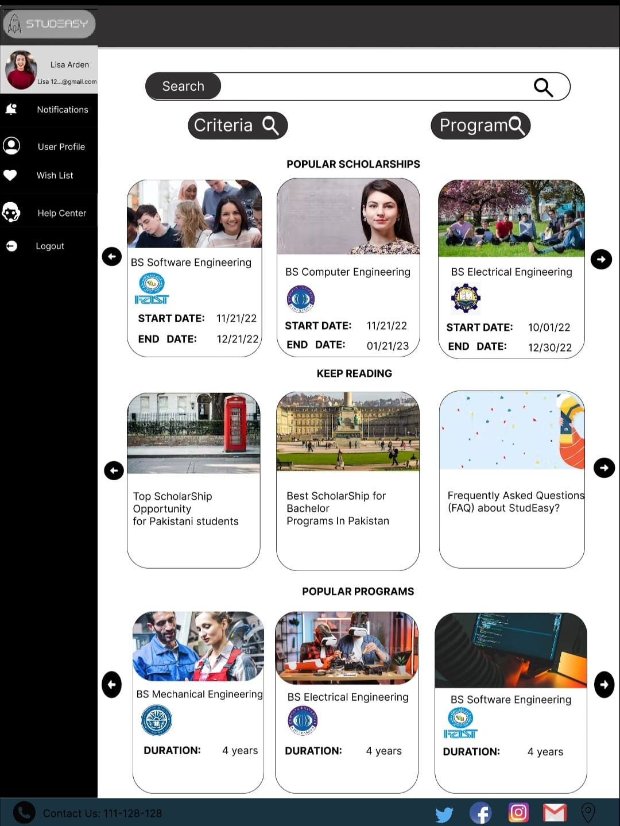

For University interface

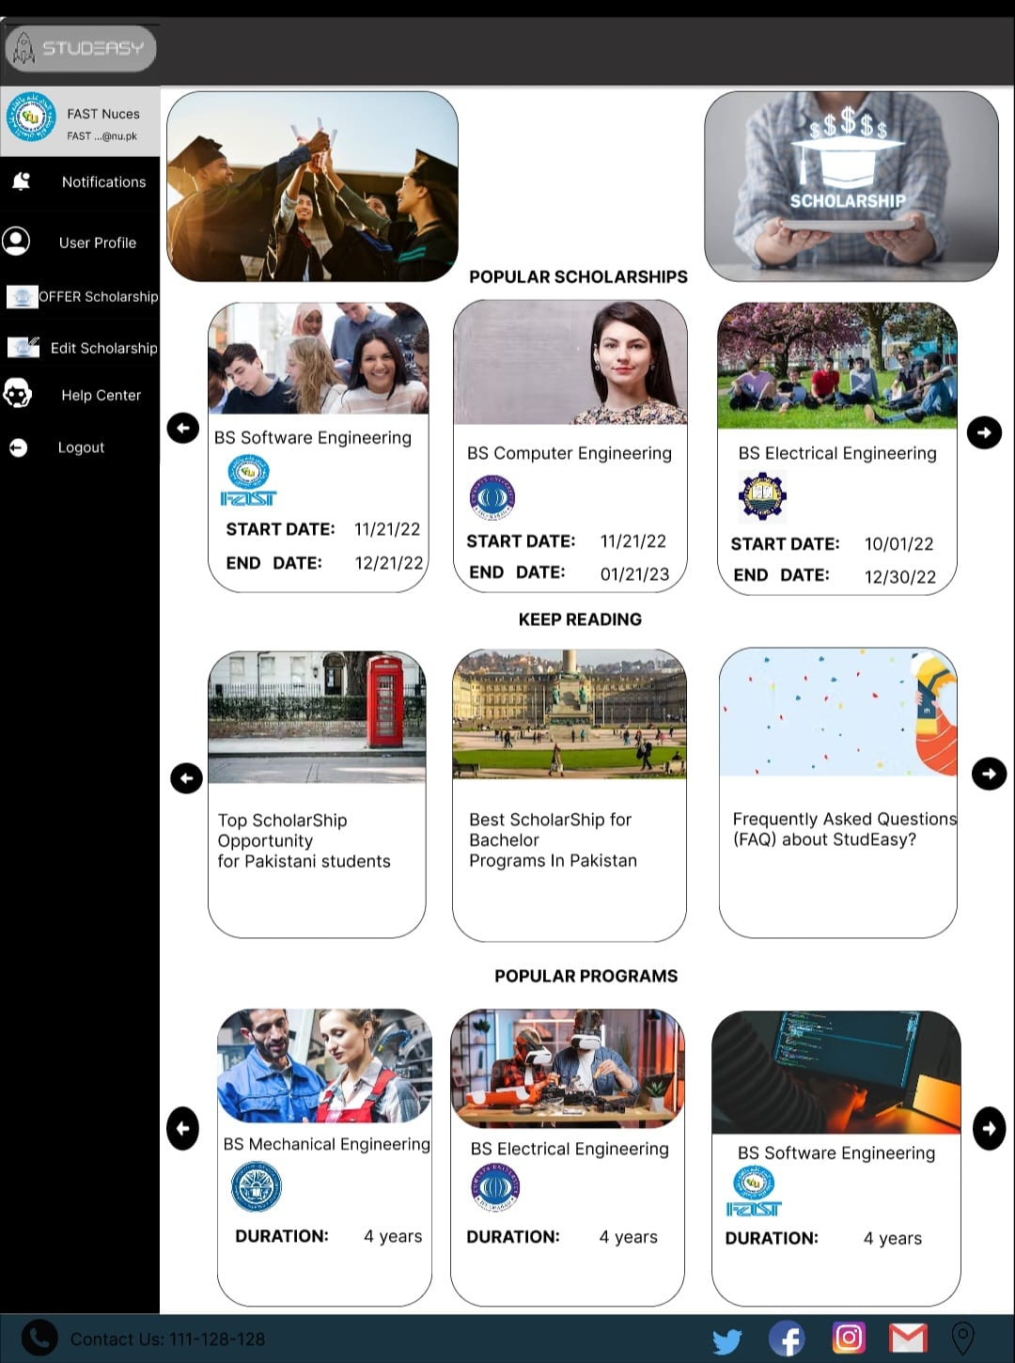

Student/University Helpline Page

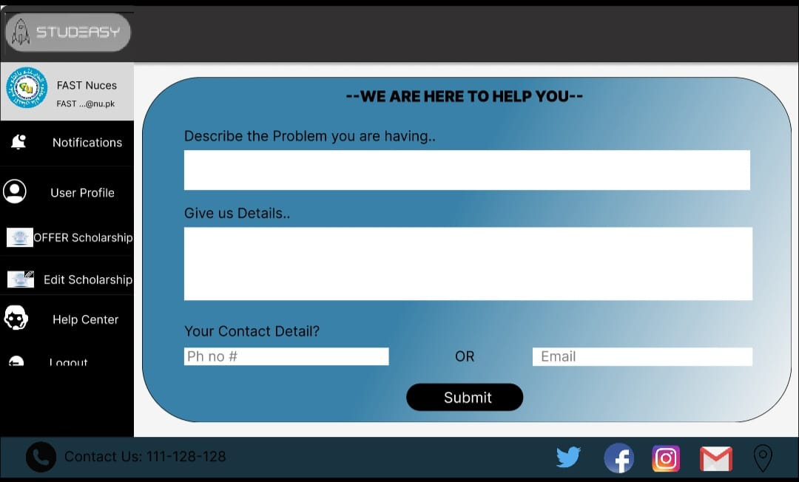
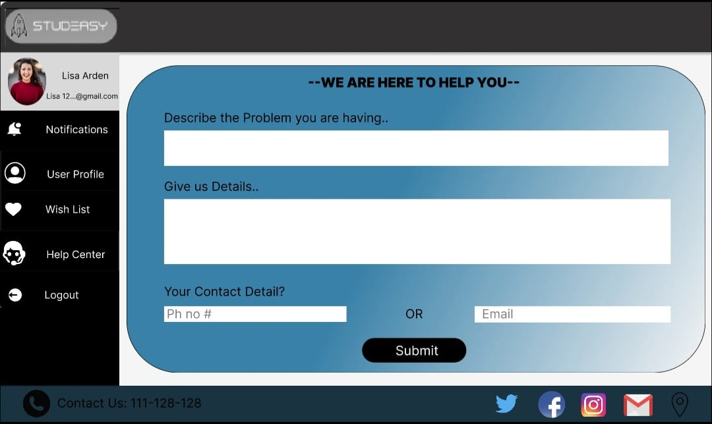

Offer Scholarship Page
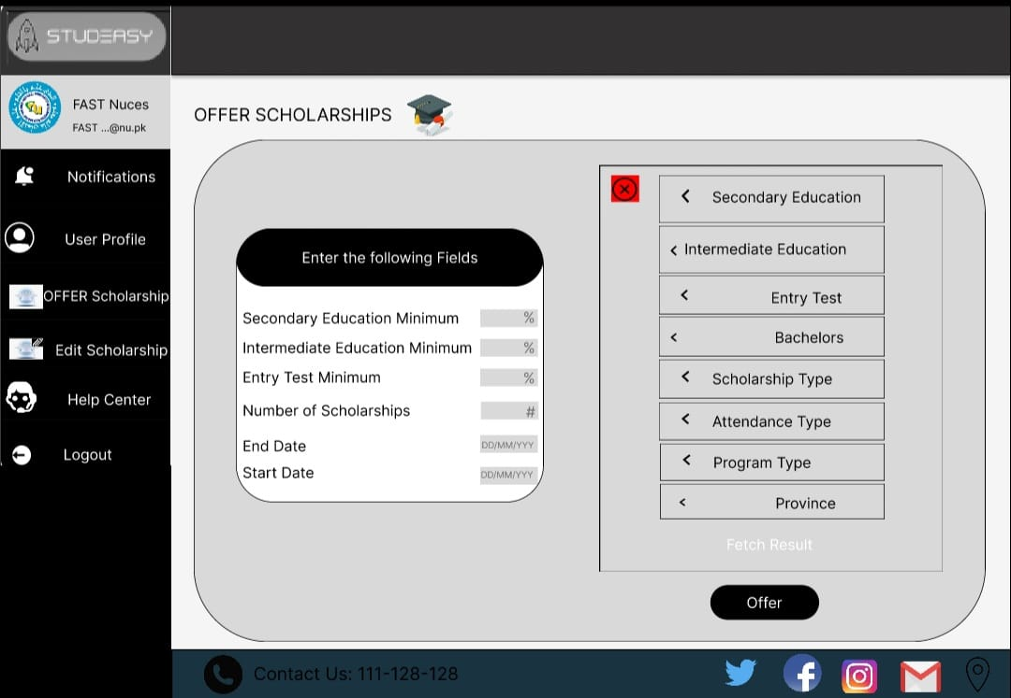

Search Results Page
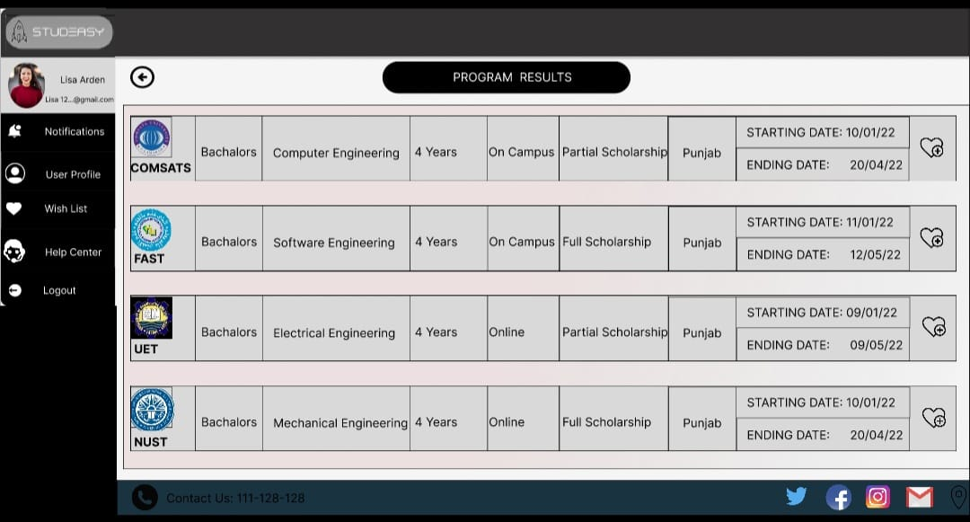

Hardware Interfaces
Since the Website must run over the internet, the system's hardware interface will be all that is needed to connect to the internet. For instance, Ethernet Cross-Cable and WAN-LAN. Because it is a web application, the interfaces will function on PCs, laptops, and mobile phones. Additionally included in the supporting systems are keyboards and mouse.

Software Interfaces
For the database, MySQL, React, PHP, and Python are the technologies that would be utilized.
- To direct students to the websites of other universities, our website will communicate with those websites.
- To provide support, our website will communicate with the CRM system.
- To display available scholarships, our website will communicate with a database.
- During the registration process, our website will communicate with the OTP service provider.
- To verify the student's personal information, our website will communicate with the NADRA database.
- To verify universities, our website will communicate with the PEC/HEC database.

Communications Interfaces
The StudEasy system will communicate over the internet using the HTTP/TCP/IP protocol. Since the SE is a web application, it will use a WIFI connection to protect the API's security. The best way to protect APIs is through Transport Layer Security (TLS) encryption, authentication, and authorization.

System Features

Search/Filter

Description and Priority
The student should be able to use the system to narrow down the universities that interest them, such as using geographical filters.

Rating against each priority component
Benefit | 8
Cost | 4
Risk | 7
Penalty | 9

Stimulus/Response Sequences

Functional Requirements

The user will be able to perform a simple search or a filter search through the system.

The search text must be entered by the user on the search bar by the system.

The system will present a variety of filter search options.

Users will be able to search through a variety of options on the system's screen.

Based on the search, the system will display all universities and scholarships that match.

On the current screen, the system should only show 15 matching results.

The system will display comprehensive information about the university or scholarship that was searched.

The system will allow users to browse for scholarship and university information.

The user should be able to move between the searches results thanks to the system.

When the Search returns no scholarships or universities that match, the system is obligated to notify the user.

FIGURE 4.1.1

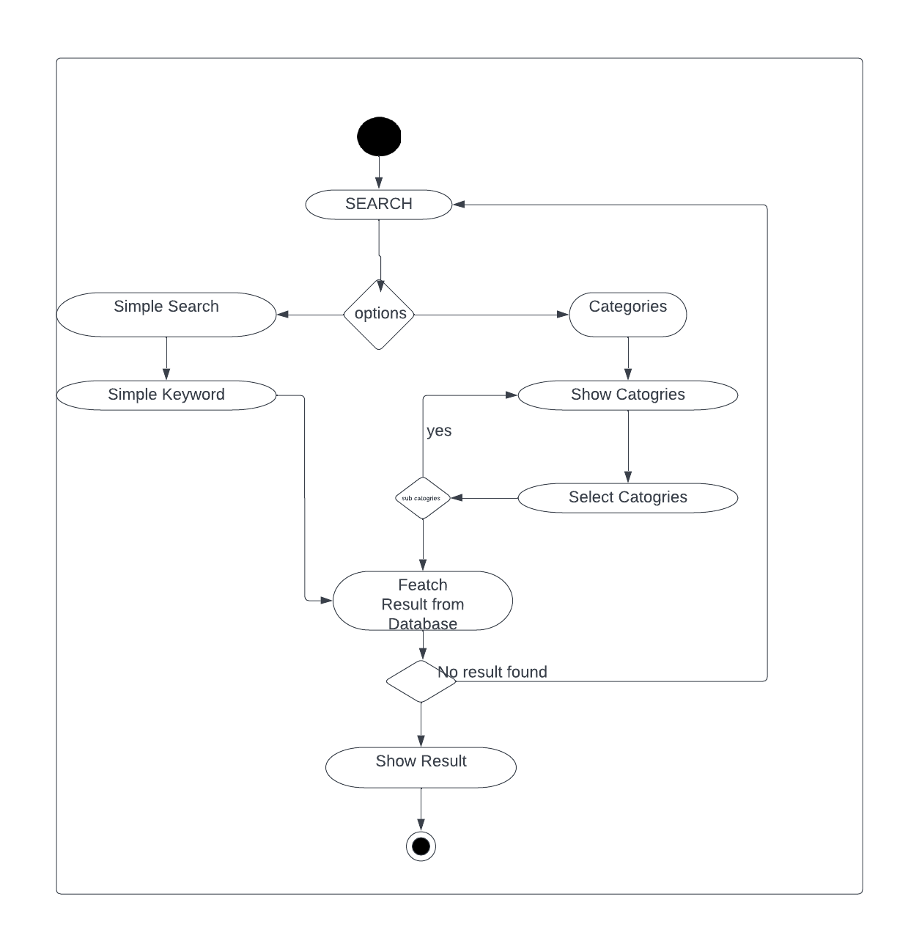

Student Profile Management

Description and Priority
The student should be able to use the system to manage their profiles with their information and data.

Rating against each priority component
Benefit | 8
Cost | 6
Risk | 6
Penalty | 8

Stimulus/Response Sequences

Functional Requirements

The user will be able to set his credentials and create a profile through the system.

The profile information should be editable by the user through the system.

Users will be able to upload their academic certificates through the system.

The user must be able to upload certificates in the png, jpg, or jpeg formats with a size of less than 2 MB through the system.

Users will be able to view their profiles through the system.

FIGURE 4.2.1

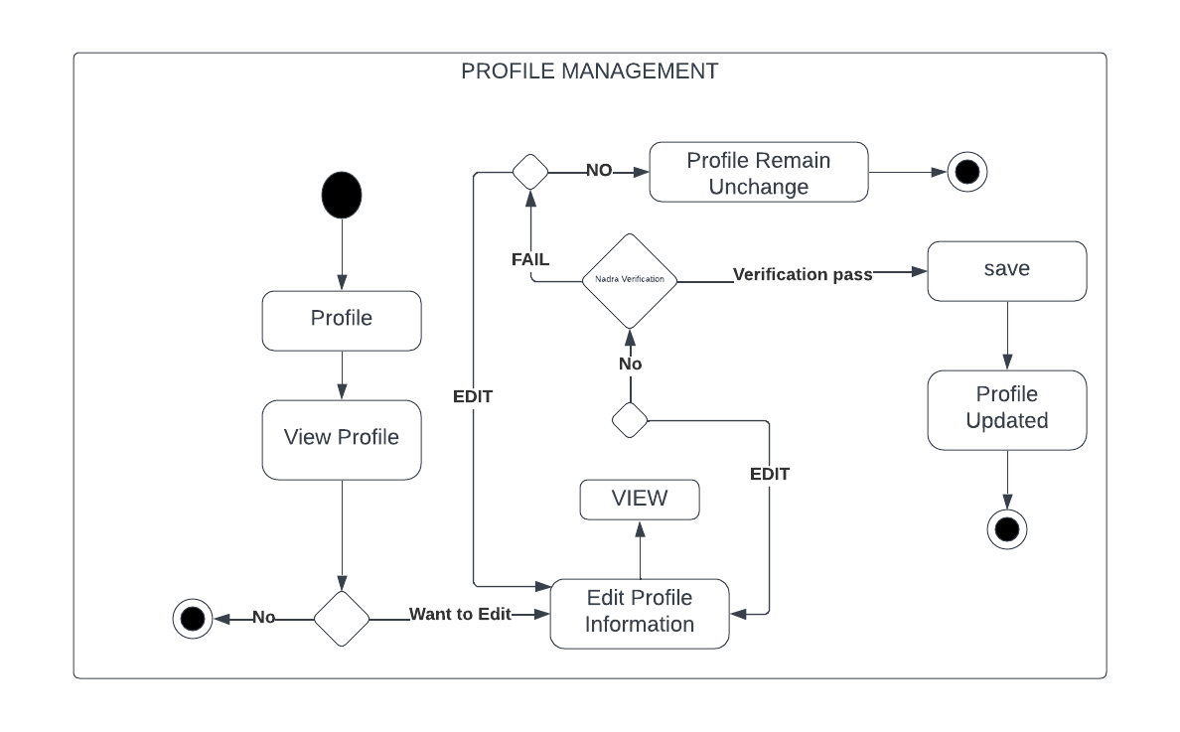

University Profile Management

Description and Priority
The university administrator should be able to use the system to manage the university profile with their information and data.

Rating against each priority component
Benefit | 8
Cost | 6
Risk | 6
Penalty | 8

Stimulus/Response Sequences

Functional Requirements

University will be able to set his credentials and create a profile using the system.

The profile information should be able to be updated or edited by university using the system.

University will be able to write a brief description thanks to the system.

University will be able to add a link to their original website to the system.

FIGURE 4.3.1:

Offer Scholarships

Description and Priority
The university administrator should be able to use the system to offer different scholarships on the portal.

Rating against each priority component
Benefit | 9
Cost | 8
Risk | 7
Penalty | 8

Stimulus/Response Sequences

Functional Requirements

Universities will be able to offer scholarships thanks to the system.

Universities will be able to simultaneously offer up to 12 scholarships thanks to the system.

Universities will be able to edit scholarship details using the system if something goes wrong.

Universities will be able to manually choose whether to open or close scholarships through the system.

Universities will be able to establish a variety of criteria thanks to the system.

Universities will be able to paste the link from their original website into the system.

After clicking their link, the system will take the student to the university webpage.

Scholarship must be closed automatically when the deadline passes.
FIGURE 4.4.1:
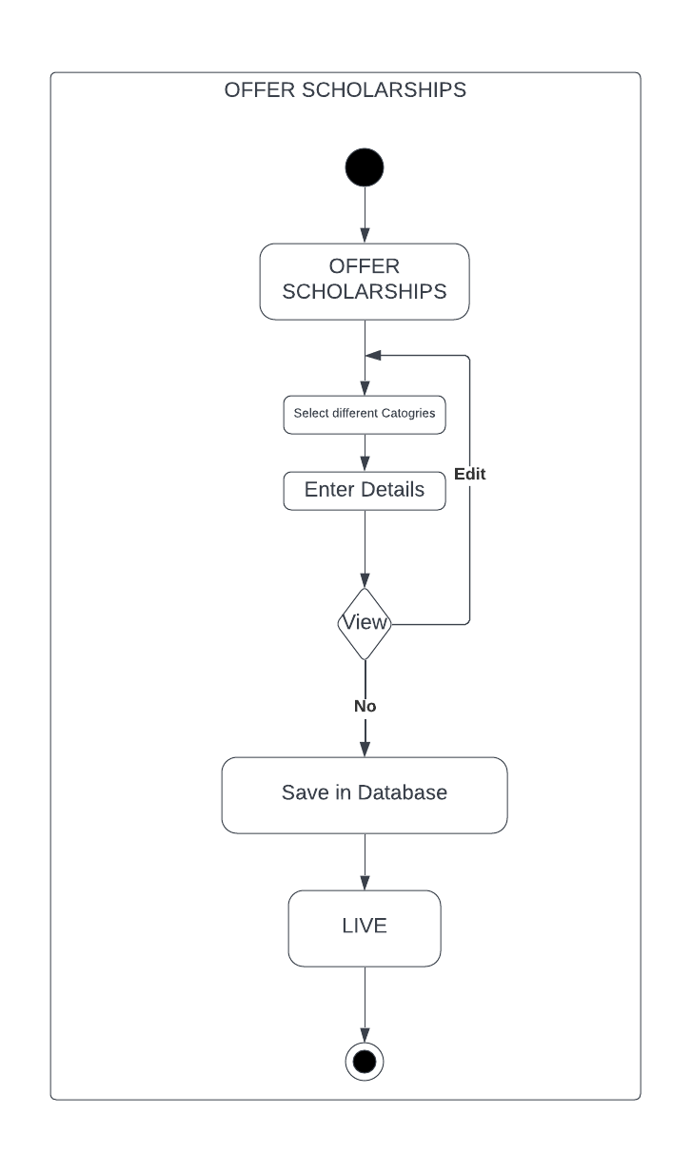

Helpline/Chat box

Description and Priority
The system has the helpline feature to assist the students.

Rating against each priority component
Benefit | 7
Cost | 6
Risk | 6
Penalty | 8

Stimulus/Response Sequences

Functional Requirements

For customer support, the system must offer options for online help and frequently asked questions.

The user should be able to choose the kind of support he wants from the system.

The phone numbers for customer support should be displayed on the screen by the system.

The user must be able to enter their issue, problem, or question for support into the system.

The user should be able to enter a phone number/email for support personnel to call/email.
FIGURE 4.5.1:
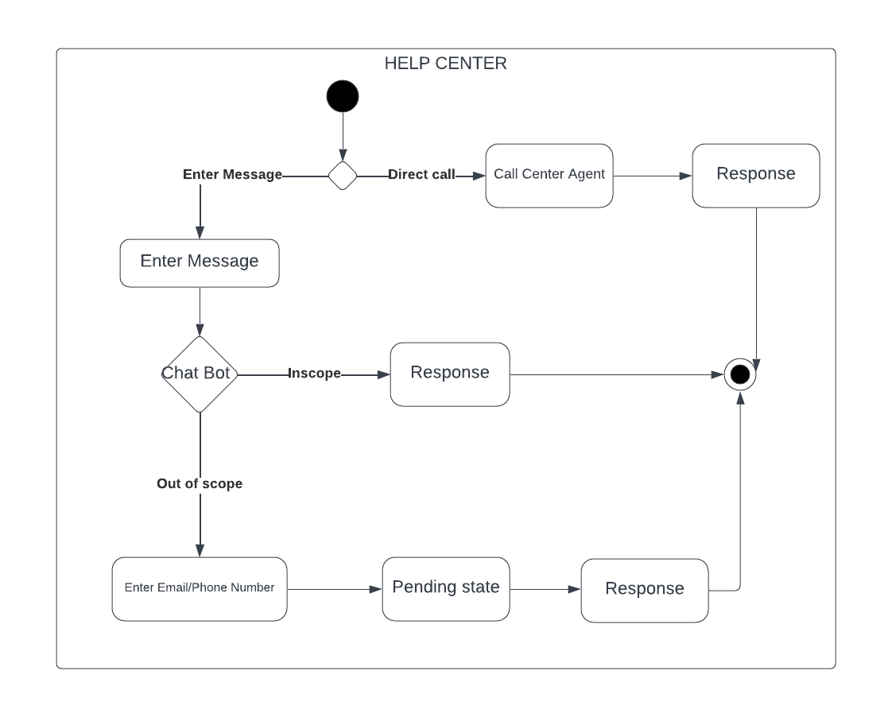

ARM TOOL:
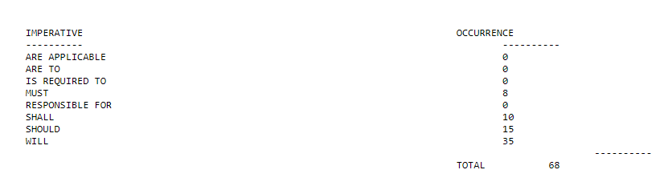

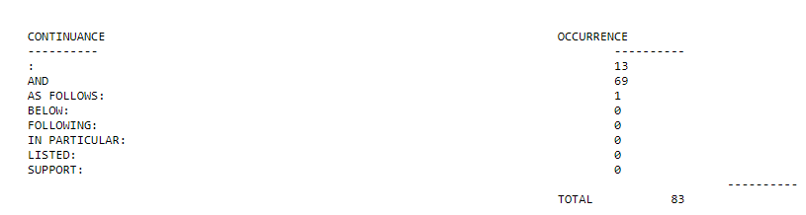
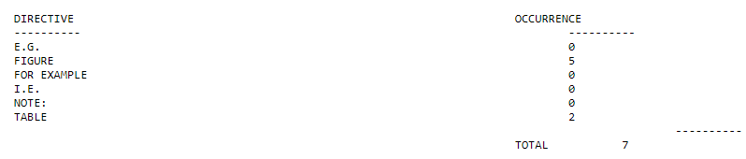
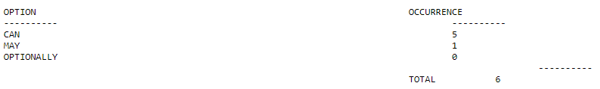
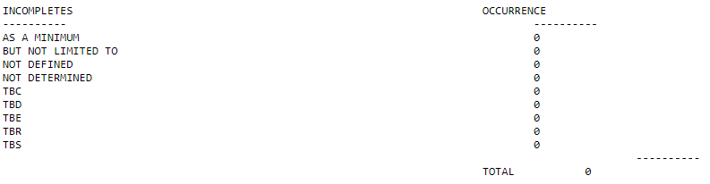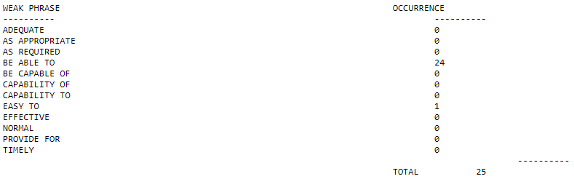
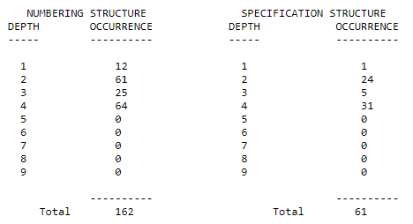

Other Nonfunctional Requirements

Performance Requirements

StudEasy should respond to every action in an average of 1.5 seconds.

If something went wrong with the system, the StudEasy shall respond in the form of an error message to the user.

StudEasy is capable of registering maximum of 100,000 student accounts and as many universities as the geographical limit of the website access allows.

Safety Requirements

StudEasy will ensure the security of the student’s data by securing the website’s URL and using authentication processes such as log in portals whenever someone wants to access their account.

Security Requirements
- StudEasy must ensure the security of API using Transport Layer Security (TLS) Encryption, Authentication and Authorization is the best way to secure the APIs.
- Maintainability and safety of the user’s account and data.

Software Quality Attributes
• StudEasy shall provide the students with the ability to shortlist the universities they are eligible for and minimizing the search effort just by performing some actions on the app.
• StudEasy shall provide the universities with the ability to offer the scholarships just by performing some actions on the app.
• The StudEasy shall provide the user with the ability to get help at any step.
• The StudEasy shall provide the user with the ability to operate on any device.
• The StudEasy shall welcome new features anytime.
• If there is no operating system error, The StudEasy should never crash or hang.
• The code of the StudEasy should be fully commented and documented.

Business Rules
Our app basically has a business rule that if a student’s data is somehow exposed or unprotected, he/she can instantly report this, a quick action shall be taken to fix the error. Similarly, if anything against the basic ethics in the feedback section is detected, the feedback shall be removed immediately and if it still doesn’t help, the user shall be blocked right away.

Other Requirements
The app shall be registered by the government as it is a part of the legal requirement for our app to perform its intended functions.
Appendix A: Glossary
StudEasy- “Financially fit for your academic progress.”
HEC- Higher Education Commision
SQL- Structured Query language
PHP- Hypertext preprocessor
API- Application programming interface
Appendix B: Analysis Models
Activity Diagram for Search/Filter
Activity Diagram for Student Profile Management
Activity Diagram for University Profile Management
Activity Diagram for Offer Scholarships
Activity Diagram for Helpline/Chat box

Appendix C: To Be Determined List
There is nothing to be determined in this document.

